Our Ref: _______________ Your Ref: ________________________ Date: __________________

Baptist Church

Baale Yaku Site Area, P. O. Box 644,

Ogbomoso, Oyo State. Tel. 07052425407

Email: [newsprinbaptistchurch@gmail.com](mailto:newsprinbaptistchurch@gmail.com)

Website: newspringbc.comze.com

NEW SPRING

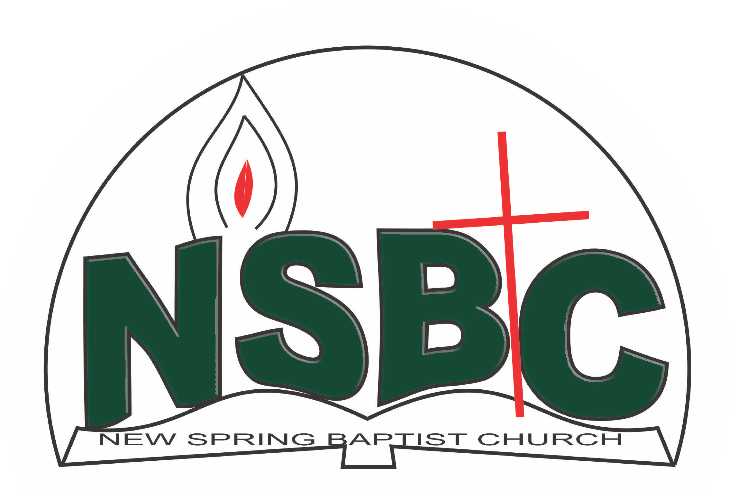

December 27, 2021

Dear Mrs. Margaret Bose Okediji,

Nomination to Serve as a Worker in the Church in 2022.

Calvary greetings in the precious name of our Lord and Saviour Jesus Christ. It is our pleasure to inform you that at the Church-in-Conference held on December 19, 2021, the Church ratified your nomination to serve in the following areas between January 1 and December 31, 2022

1. Member, Intercessors’ Committee under the chairmanship of Mrs. Funke Oyekunle
2. Member, Visitation Committee under the chairmanship of Mrs. Ruth Olanrewaju
3. Vice-President/Song Leader, Women Missionary Society (WMS)

Please refer to the table below for the key functions of each of these roles. Details can be found in the Church constitution. You are strongly encouraged to become familiar with the tasks as stated in the document. There will be an orientation of the Church workers on January 15, 2022 at 8:30 a.m. on the church premises. Please ensure you participate in this training.

“Now it is required that those who have been given a trust must prove faithful. I Corinthians 4:2”. May God find you faithful in the task He has assigned to you.

| Domain | Key function of Office, Department or Committee |
| --- | --- |
| Intercessors’ Committee | Responsible for standing in the gap on behalf of the Church and her members |
| Visitation | Visit members and worshippers at home or special institutions with a view to encouraging them in their Christian walk and reporting on pertinent issues that may require Church intervention and appropriate action |
| Vice-President/Song Leader, WMS | Assist WMU President to prepare women, young ladies/girls and children for mission |

Thank you for accepting to serve in this Church.

Yours in His service

‘Sayo Okediji Blessed Agboola

Church Secretary Chairman, Nominating Committee